**The impact of structural changes on forecast performance: an example**

In this supplementary material, we demonstrate the impact of structural changes on forecast performance using an example based on simulation. We denote that the price variable $x_{t}$ has its values being 2.99 for most of the weeks but occasionally get reduced to 2.29 or 1.99. We assume the following unobserved true product sales:

$y_{t}=10-1.5x_{t}+u_{t}$, $u_{t}\sim NID(0,0.1)$, when $t<25$

$y_{t}=5-0.7x_{t}+u_{t}$, $u_{t}\sim NID(0,0.1)$, when $25<t<50$

$y_{t}=10-1.5x_{t}+u_{t}$, $u_{t}\sim NID(0,0.1)$, when $t>50$

(1)

where $y_{t}$ and $x_{t}$ represent the product sales and the price at week *t*, and $u_{t}$ is the error term. Thus, there are two structural changes which occur at week 25 and 50 respectively. Suppose that we have the data from week 1 to week 75 and we want to forecast the product sales for the period from week 76 to week 100. The sales and price are shown in Figure 1.

Figure 1. The predictions and forecasts by [1]

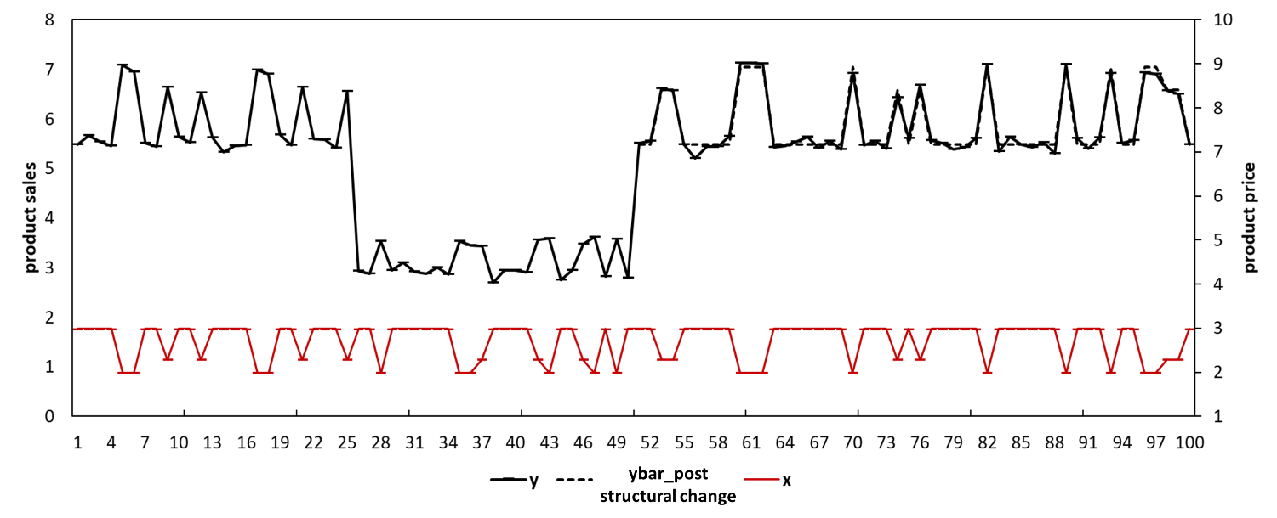

We may develop a congruent model (i.e., $y_{t}=a+bx_{t}+u_{t}$). If we know the presence of the structural change, we may estimate this model exclusively using the post-structural change data (e.g., data from week 51 to week 75) and generate unbiased forecasts. We refer this model as $model (post structural change data).$ Figure 1 shows its predictions/forecasts (i.e., “ybar_post structural change”). Table 1 shows its forecast performance (e.g., with MAE= 0.09, MSE= 0.01, MAPE= 1.5%, and SMAPE= 1.5%).

If we overlook the presence of the structural changes, we may estimate the model using all the available data (i.e., from week 1 to week 75). We refer this model as $model (all data).$ Figure 2 shows its predictions/forecasts (i.e., ybar_1). Table 1 shows its forecast performance (e.g., with MAE= 0. 949, MSE= 0. 961, MAPE= 15.8%, and SMAPE= 17.2%). The model gets outperformed by $model (post structural change data).$.

Figure 2. The predictions and forecasts by $model (all data).$

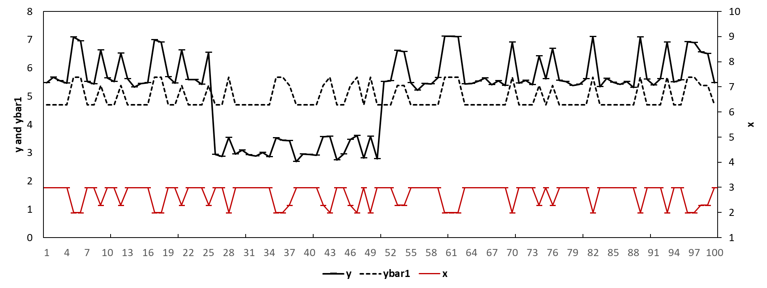

Table 1. The forecasting performance of different models in the simulation

|  |  |  |  |  |
| --- | --- | --- | --- | --- |
| Model | MAE | MSE | MAPE | SMAPE |
| The model estimated with all available data | 0.95 | 0.96 | 15.8% | 17.2% |
| The model estimated with post-structural change data | 0.09 | 0.01 | 1.5% | 1.5% |
| The model with intercept correction | 0.20 | 0.07 | 3.2% | 3.2% |
| The model with estimation window combining | 0.86 | 0.80 | 14.2% | 15.4% |

We may implement the estimation window combining (EWC) method for $model (all data)$ if the presence of any structural change is detected. We detect the presence of any structural change using a sequential Chow (1960) test. For example, we conduct the Chow (1960) tests each time assuming there is a structural change occurring at one of the weeks, for up to 95% of the estimation period. We reject the null hypothesis of no structural change if the we detect structural changes for any of the weeks. Figure 3 plots the p-values of the sequential Chow test. The plots indicate that the p-values for some of the weeks (e.g., those closed to week 25 and 50) are extremely small (e.g., close to zero), which suggests the presence of structural changes. Alternative tests (e.g., considering multiple breaks, heteroskedasticity, and unit roots etc.) are available but require additional priori knowledge and assumptions such as the number and the locations of potential structural changes (Donald W K Andrews, 1993; Donald W. K. Andrews & Ploberger, 1994; Bai & Perron, 1998, 2003).

Figure 3 p-values of the sequential Chow test for each observation

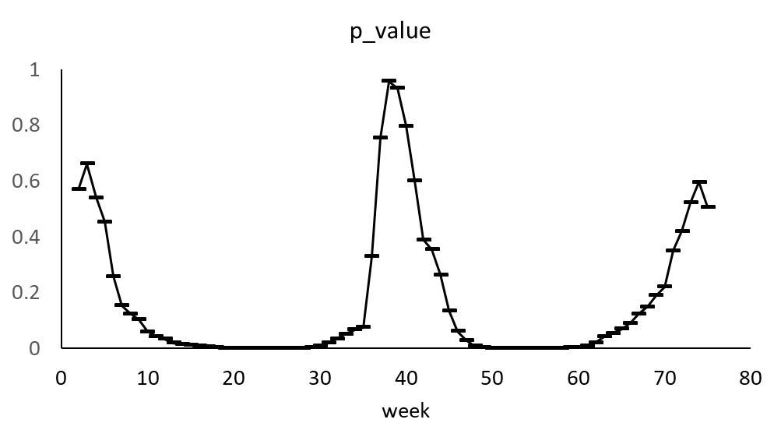

Therefore, we confirm the presence of structural changes, and we consider the forecasts as biased. We thus implement the EWC method by combining the forecasts by $model (all data)$ with different estimation windows. For example, we estimate the model using the data [1, 75], and generate the forecasts which are subject to the full bias (referred to as $f_{1}$). We then estimate the model using the data [2, 75], and generate a second set of forecasts (referred to as $f_{2}$), and so forth. The forecasts including $f_{2}, f_{3}, and f_{s}$ are less biased compared to $f_{1}$ but associated with inflated forecast error variance as they were generated using less information. In this example, we arbitrarily choose $s$ to be 60, which gives us 60 sets of forecasts. We obtain the final forecasts as the average of the 60 sets of forecasts. We refer this model as $model (EWC).$ Figure 4 shows its forecasts (e.g., ybar_EWC). Table 1 shows its forecast performance (e.g., 0. 86 for MAE, 0. 80 for MSE, 14.2% for MAPE, and 15.4% for SMAPE). $model (EWC)$ outperforms $model (all data).$.

Figure 4. The predictions and forecasts by $model (EWC).$

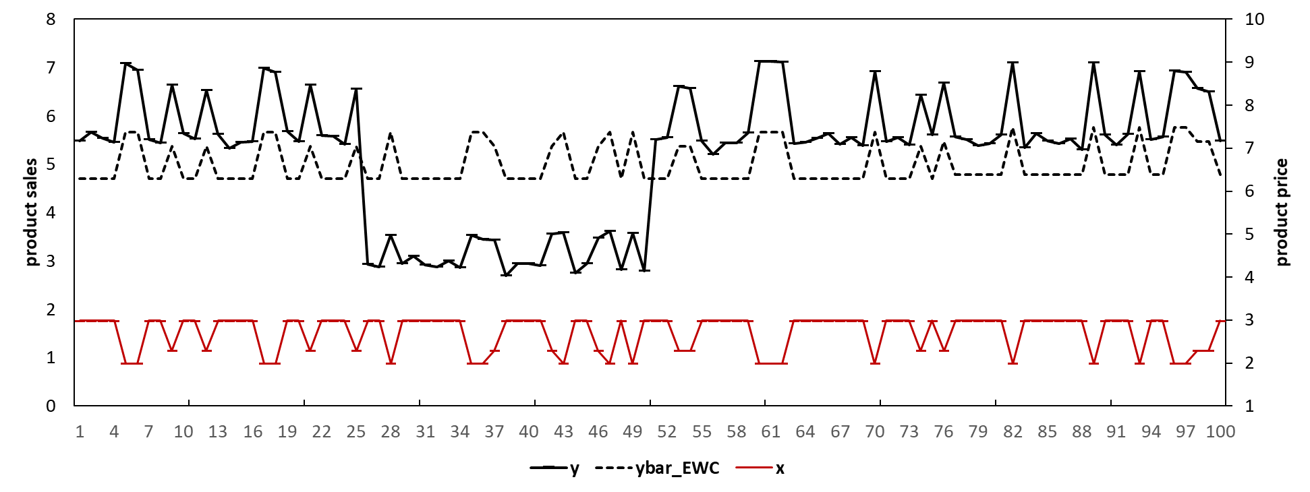

In Figure 4, the black dashed line for the period [1, 75] represents the predictions by $model (all data).$ The black dashed line for the period [76, 100] represents the predictions by $model (EWC)$.

We can also the intercept correction (IC) method for $model (all data)$ given that we have detected the presence of the structural change using the sequential Chow test. We may estimate the forecast bias as the average value of an ad hoc number (e.g., we choose four in this example) of the errors close to the forecast origin. e.g., ${\hat{Bias}}_{IC}=\sum_{t=71}^{t=75}{(\frac{y_{t}-{\hat{y}}_{t}}{4})}$ where ${\hat{Bias}}_{IC}$ is the estimated forecast bias. We obtain the final forecasts by adding the estimated bias back to the forecasts by $model (all data)$. We refer to this model as $model (IC).$ Figure 5 shows its predictions/forecasts (e.g., ybar_IC). Table 1 shows its forecast performance (e.g., with MAE= 0.2, MSE= 0.07, MAPE= 3.2%, and SMAPE= 3.2%). $model (IC)$ outperforms $model (all data).$.

Figure 5 The predictions and forecasts by $model (IC).$

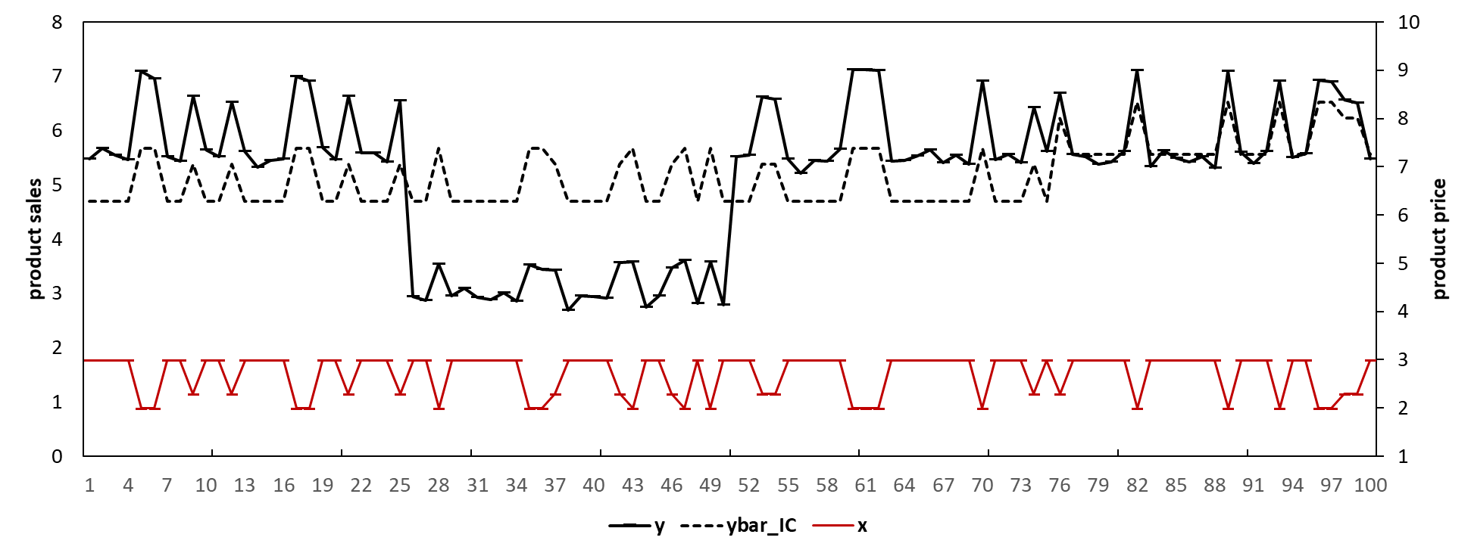

Reference:

Andrews, D. W. K. (1993). Tests for Parameter Instability and Structural Change with Unknown Change Point. *Econometrica, 61*, 825-851.

Andrews, D. W. K., & Ploberger, W. (1994). Optimal tests when a nuisance parameter is present only under the alternative. *Econometrica, 62*, 1383-1414.

Bai, J., & Perron, P. (1998). Estimating and Testing Linear Models with Multiple Structural Changes. *Econometrica, 66*, 47- 78.

Bai, J., & Perron, P. (2003). Computation and Analysis of Multiple Structural-Change Models. *Journal of Applied Econometrics, 18*, 1-22.

Chow, G. C. (1960). Tests of Equality Between Sets of Coefficients in Two Linear Regressions. *Econometrica, 28*(3).

1. In Figure 1, we highlight the period before the first structural change (e.g., week [1,25]) in blue. We highlight the period after the second structural change but before the forecast origin (e.g., week [51, 75]) in yellow. We highlight the period between the two structural changes (e.g., [26, 50]) in green, and we highlight the forecast period (e.g., week [76, 100]) in red.